[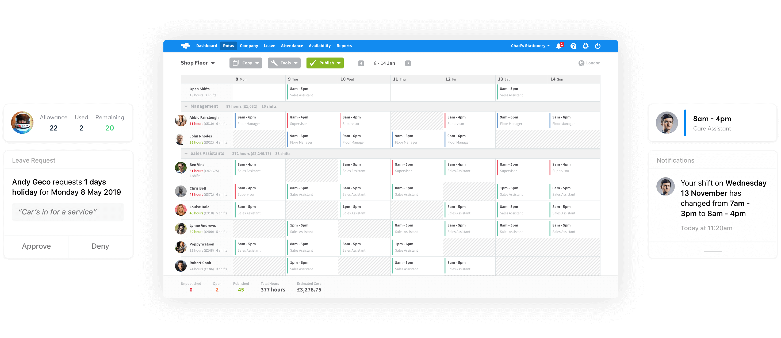https://rotacloud.com/care-homes/](https://rotacloud.com/care-homes/)

you can drag n drop the dates

“Your team always have access to the very latest version of their rota, with any tweaks or updates immediately communicated via text, email, or push notification, so you can be sure that everyone’s in the loop.”

“ You don’t have to be tech-savvy to use RotaCloud. Drag and drop shifts, colour code roles to easily check carer coverage, and view detailed staffing graphs and reports in just a few clicks.”

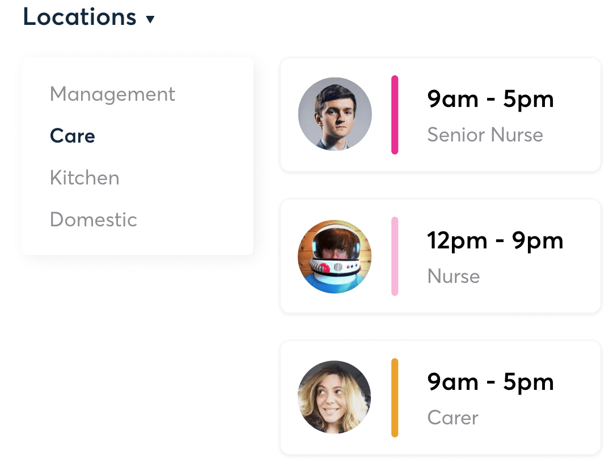

“Sleep-ins, sorted

Set a flat rate to apply to all sleep-in shifts, or an hourly rate — whichever your company uses. Compile accurate wage data for payroll in seconds — no more manually typing into spreadsheets.”

[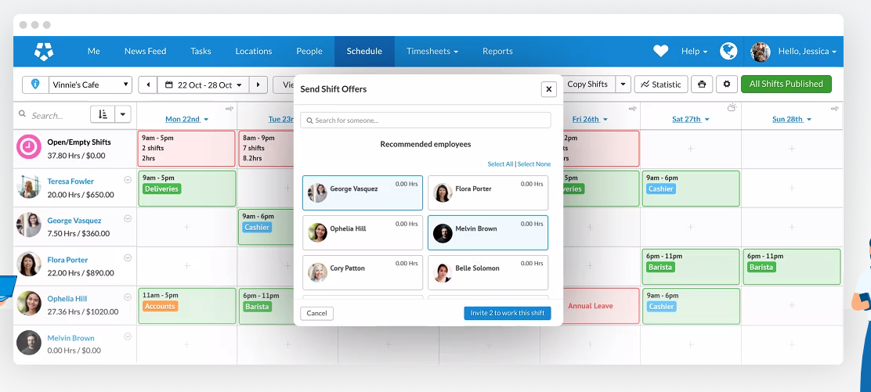](https://www.shiftboard.com/product/scheduling-software/?utm_campaign=Software+Review+Site&utm_medium=EmployeeScheduling-VisitWebsite&utm_source=capterra)

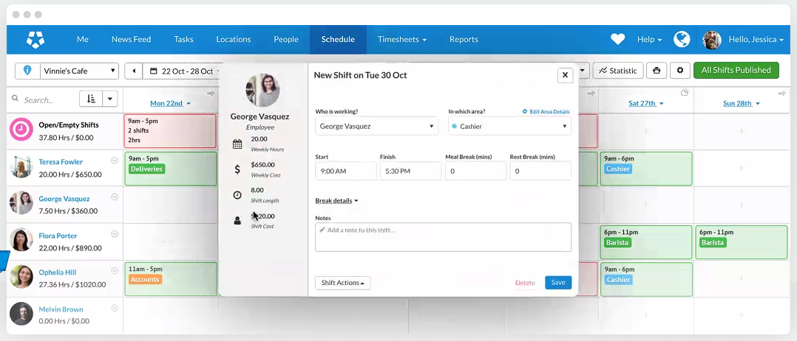

To share files

Web Share API

https://css-tricks.com/how-to-use-the-web-share-api/

<https://developer.mozilla.org/en-US/docs/Web/API/Navigator/share>

https://jsfiddle.net/ericwilligers/8cpuskqd/

An open source GPDR compliant ‘Whats App’

<https://jami.net/>

<https://www.shiftboard.com/product/scheduling-software/?utm_campaign=Software+Review+Site&utm_medium=EmployeeScheduling-VisitWebsite&utm_source=capterra>

“Reduce labor costs, eliminate no-shows, improve team communication, and streamline operations. Move beyond spreadsheets with Shiftboard’s employee scheduling software.”

Health Rota

<https://healthrota.co.uk/>

